Dublin Scioto Theatre
Presents

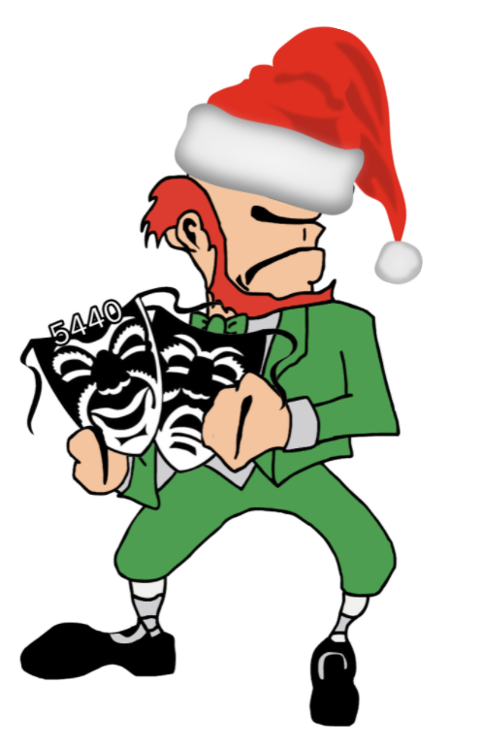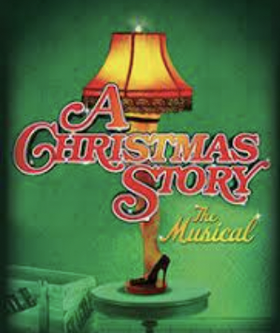

Audition Information
Book by Joseph Robinette

Music and Lyrics by Benj Pasek and Justin Paul
Based upon the motion picture, A Christmas Story
Written by Jean Shepherd, Leigh Brown and Bob Clark

High School Auditions: September 26
Children’s Auditions: September 27

Performances: December 2, 3, 4

Rehearsals begin October 4

Audition Information
How to Prepare for Auditions

- Read the description of the show and the descriptions of the characters.
A Christmas Story, The Musical libretto
A Christmas Story, The Musical score

- Read the rehearsal contract carefully. Share and discuss with your parents/ guardians. Being in a show is a commitment.

- Please fill out the audition form. You must fill this form out before auditions. Auditions are September 26.

- Pick a character and prepare one of the provided monologues/ songs.

- There will be a required parent meeting on Tuesday, October 4 at 7:00 PM in the auditorium.

- Please be aware that casting is done by a panel of judges who compile scores. We want to cast the best show possible. Dublin Scioto Theatre has a “no pouting” policy with regard to casting. Not getting the role you want can be disappointing, but being willing to take the role you get and make it the best it can be is what performing is all about! There are no small parts - everyone is part of the same team.

- Everyone must attend the dance audition from 3:00 - 4:00 PM on September 26. You will be taught a combination and you will perform in groups for the choreographer.

About the show…
Set in the 1940s in the fictional town of Hohman, Indiana, the musical follows 9-year-old Ralphie Parker and his quest for the Holy Grail of Christmas gifts—an Official Red Ryder carbine-action 200-shot Range Model BB gun. Rebuffed at every turn with a similar echoing response, Ralphie plots numerous schemes to achieve his desperate desire for the coveted BB gun. All the iconic scenes from the movie are here: Ralphie's friend, Flick, getting his tongue stuck to the flagpole; his brother, Randy, getting dressed in his snowsuit; the bullies, Farkus and Dill; the leg lamp award; the bunny suit; Christmas dinner; and many others. The delightfully versatile score ranges from gentle ballads to show-stopping full-ensemble numbers such as "Ralphie to the Rescue!", "A Major Award," "Sticky Situation," "Up on Santa's Lap," "Somewhere Hovering Over Indiana" and the inevitable "You'll Shoot Your Eye Out!" A Christmas Story, The Musical will bring an exciting new dimension to those who have seen the movie and will certainly stand on its own for those who haven't.

Characters for high school students

Jean Shepherd/ Narrator: A charismatic storyteller who has the ability to weave a spell and draw the audience into his magical world. He is omniscient, but not overpowering - a good-natured curmudgeon with a deadpan sense of humor. He holds the audience with his tremendous presence and spark. When he is onstage as the narrator he is unnoticed by the other characters except for a few occasions when he has direct interaction with Ralphie.
Monologue 1 Monologue 2
Mother : More in charge of her family than the Old Man is, but she would never let him know it. She is warm and friendly… at times a bit daffy… but not a pushover. A vibrant woman, whe is always busy, especially any time she’s in the kitchen. She is the secret engine that keeps the family running, keeping the household together with an impressive balancing act.
Monologue/ Music
What a Mother Does accompaniment

The Old Man (Ralph’s dad): A guy with a good heart, though it is buried beneath a sometimes gruff (and rough) exterior. He’s a devoted husband and father who loves his family but doesn’t overtly show it. He usually expects the worst but is capable of excitement if the situation warrants (though it usually doesn’t). In his moments of fantasy, he is transformed from his usual grumbling, blue-collar self to a true song and dance man.
Monologue and music
Genius on Cleveland Street accompaniment

Scut Farkus: should look 14 to 15-years-old. The textbook example of a schoolyard bully, except this truant doesn’t go to school. He is loud, obnoxious, and intimidating. Older than Ralphie and his classmates, he wears a perpetual scowl beneath his trademark coonskin cap. He always appears at the most inopportune times to scare and harass his innocent victims.
Monologue
Shoot Your Eye Out accompaniment
Santa Claus: The Santa Claus at Higbee’s Department Store is decidedly unlike the typical “Jolly Old Elf” of legend and lore. Ill-tempered, to say he is unhappy with his job would be an understatement. He dismisses each child as quickly as possible in an attempt to put an end to the day and go home.
Scene and song
Santa’s Lap accompaniment

Chief Elves: They hate kids and they’re not too fond of Santa either! They just want the evening to be over so they can go home.
Scene and song
Santa’s Lap accompaniment
Miss Shields: The local elementary school teacher. A seemingly stereotypical 1940s educator - prim and proper. Stern when necessary, though warm – and even humorous – when the situation merits it. In Ralphie’s fantasy, she becomes a dynamic, show-stopping, brassy belter and tapper - a force to be reckoned with.
Monologue and song
Shoot Your Eye Out accompaniment
Shoot Your Eye Out End accompaniment

Elves: Song
Santa’s Lap accompaniment

For the following roles: please sing EITHER
“It All Comes Down to Christmas or
“A Major Award”.
Comes Down to Christmas accompaniment
Major Award accompaniment

Mrs. Schwartz: the mother of Ralphie’s classmate, Schwartz.
Scene - Page 73

Flick’s Mother: the mother of Ralphie’s classmate, Flick.
Nancy’s Mother:
Kid 4’s Mother:
Kid 4’s Father:
Fantasy Villain:
Grouchy Townsman:
Bank Manager:
Bank Robbers:
Escaped Prisoner:.
Can-Can Girlfriend:
Can-Can Girls:
Delivery Men:
Policeman:
Fireman:
Doctor:
Nurse:
Waiters/ Waitresses:
Ensemble - Neighbors, Shoppers, Parents, Students, Townspeople & Others:
Song - Major Award

A CHRISTMAS STORY Rehearsal Contract

Please make a copy of this form, have a parent or guardian sign it electronically, then EITHER share it with Dr. Santanello (santanello_patricia@dublinschools.net) OR bring a hard copy to your audition.

- I understand that all company members are required to attend all rehearsals for the full duration of each rehearsal, unless otherwise notified.
- I understand that rehearsals are held from 3:00 - 5:30 PM in person. During the week of the show, rehearsals will go until 8:00 PM.
- I understand that it is my responsibility to check the schedule for rehearsals in Schoology and on the Callboard and to make my parents/guardians aware of the times and days for which I am scheduled.
- I have turned in a list of my current obligations, other than production work, on my audition form. I agree not to add any obligations that will prevent me from attending rehearsals during the times I have committed to be available.
- I agree to make the director(s) aware at least one week ahead of time, of any short-term, emergency obligation that must be scheduled around; otherwise, I am expected to be at the rehearsals for which I’m scheduled.
- I agree to be on time for all rehearsals.
- In case of emergency, I agree to let the director(s) know of my late arrival or absence as soon as possible.
- I agree to fulfill my responsibilities and meet deadlines. Lines and lyrics must be memorized by Wednesday, November 2. Failure to have lines memorized will result in a reduction of Thespian points!
- I agree to cooperate with all staff and students involved in the production.
- I agree not to use this production as an excuse for not fulfilling my other obligations, such as class work. I understand that this is an added, voluntary activity.
- All company members are required to pay a $40 supply fee. This will be collected at the parent meeting. If you are unable to pay the fee, scholarships are available without question.
- All company members are required to have a parent or guardian attend the Parent Meeting on Tuesday, October 4 in the auditorium. One parent must be there.
- I understand that I could be dismissed from the production for missing three unexcused rehearsals, lateness, missing deadlines, lack of cooperation, or grade problems.
- I understand that I am bound by the Extracurricular Code of Conduct and it is my responsibility to read the Code and abide by it.

I, the student ______________________________ have read the responsibilities described for production work. I agree to fulfill these responsibilities.

Signature ________________________________________ Date ___________________

I, the parent / guardian _____________________________ have read the responsibilities described for production work. I understand that my child (the above named student) has agreed to fulfill these responsibilities.

Signature ______________________________________ Date _____________________

