Dublin Scioto Theatre
Presents

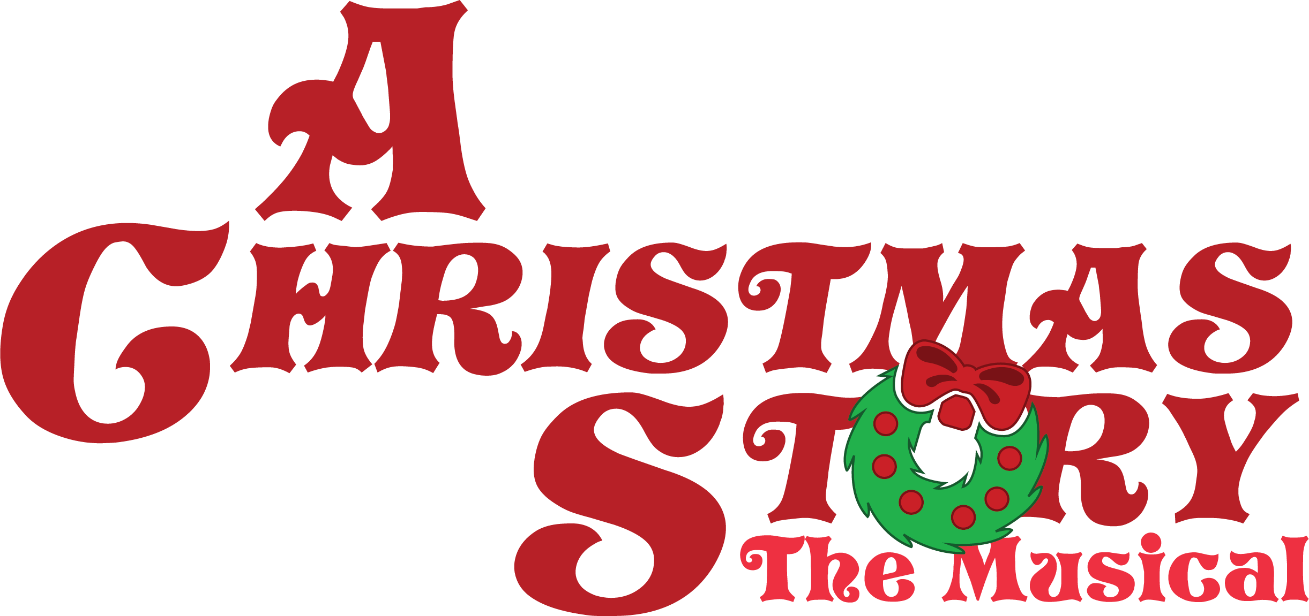

Music by Benj Pasek and Justin Paul
Book by Joseph Robinette
Lyrics by Benj Pasek and Justin Paul

Children’s Auditions: September 27
4:00 – 8:30 PM ONLY
Performances: December 2 7:30 PM
December 3 2:00 PM Sensory and Family Friendly Performance
December 3 7:30 PM
December 4 2:00 PM

CHILDREN’s AUDITION INFORMATION
Auditions for Dublin Scioto’s
A Christmas Story, the Musical

From the songwriting team behind Dear Evan Hansen, La La Land, and The Greatest Showman, the beloved 1983 movie to musical is brought to life on stage in A Christmas Story, The Musical! Set in 1940s Indiana, a young and bespectacled Ralphie Parker schemes his way toward the holiday gift of his dreams, an official Red Ryder Air Rifle. A leg lamp, pink bunny pajamas, and a freezing flagpole are just a few of the distractions that stand between Ralphie and his Christmas wish.
Available roles for children:

RALPHIE PARKER- Age 9, going on 10 (could be played by a 9 to 12-year-old). Cute, but no precious. Bright, but not precocious. A regular kid you wouldn’t mind having as a next-door neighbor. He’s a bit mischievous and rascally, but with a twinkle in his eye.
Ralphie must be able to sing, act, and move well. Most of all, he needs great stage presence, because he is on stage for most of the show. We are hoping to double-cast this role.
Monologues and songs
Red Ryder Accompaniment

RANDY PARKER - Age 7 - 8. Ralphie’s younger brother. Cute, cuddly, and whiny. Admires Ralphie but won’t admit it. He’s at the stage of childhood wherein he seems opposed to everything, but he’s still lovable - not a brat.
Monologue and song
Somewhere Hovering Accompaniment

FLICK - Age 9, going on 10 (could be played by a 9 to 12-year-old). Ralphie’s best friend and classmate. Flick is the guinea pig in the flagpole licking experiment. Sings some solos, so should have a good voice and comedic timing.
Monologue and song
Somewhere Hovering Accompaniment

SCHWARTZ (Age 9-10). One of Ralphie’s classmates and best buddies. Schwartz becomes the scapegoat shen Ralphie utters an unmentionable word. Sings some solos, so should have a good voice and comedic timing.
Monologue and song
Somewhere Hovering Accompaniment

GROVER DILL (Age 9-10). Grover is Farcus’s toady and always at his side. Grover delights in being tethered to his “hero”. He laughs at Farcus’s antics.
Scene

ESTHER JANE (9-11) Classmate of Ralphie and the object of his reluctant affection, neighborhood kid. She is the teacher’s pet.
Scene page 92
Somewhere Hovering Accompaniment

MARY BETH (9-11) Classmate of Ralphie, neighborhood kid. She is impatient and a bit of a know-it-all.
Scene page 92
Somewhere Hovering Accompaniment

NANCY (9-13) Classmate of Ralphie.
Somewhere Hovering Accompaniment

GOGGLES KID
Somewhere Hovering Accompaniment

KID 1
KID 2
KID 3
KID 4
KID 5
Somewhere Hovering Accompaniment

VOCAL SCORE: A Christmas Story

LIBRETTO: A Christmas Story Libretto

Auditions: Tuesday, September 27 4:00 – 8:30 PM ONLY

- Please read the description of the show and the descriptions of the characters.

2. EVERY CHILD MUST BE AT THE DANCE AUDITION AT 4:00 PM. The choreographer will teach everyone a dance combination for the audition.

3. Rehearsals begin Tuesday, October 4.

4. Please fill out the audition form before auditions. We would appreciate a small photograph of each child auditioning (please bring to auditions) so that we remember who your child is.

5. Please sign up for an audition time

6. A parent or guardian must attend the mandatory meeting on Tuesday, October 4 at 7:00 PM in the DSHS Auditorium.

7. Each family must sign a Dublin City Schools Waiver of Liability Form (below) for each child participating and bring this to auditions or email to Dr. Santanello.

Tentative rehearsal dates:
October 4, 5, 6, 10,11, 12, 13, 17, 18, 20, 24, 25, 26, 27
November 1, 2, 3, 7, 8, 9, 10, 11, 14, 15, 16, 17, 18, 21, 22, 28, 29, 30
December 1 Performances December 2, 3, 4

DUBLIN CITY SCHOOLS WAIVER OF LIABILITY, ASSUMPTION of RISK and INDEMNITY AGREEMENT for PARTICIPATING ADULTS and MINORS
In connection with and consideration of my participation on School premises, I, hereby represent and agree as follows: 1. I am aware that participation in any activity on the School’s premises can potentially be dangerous, and I fully recognize and understand that there are risks and hazards, both minor and serious, associated with participation in the School, on the School’s premises and related activities, including, but not limited to: cuts, scrapes, bruises, broken bones, muscle strains, pulls or tears, head, neck, back, eye and other bodily injuries, heat exhaustion, heat stroke, frostbite, brain damage, blindness, deafness, drowning, heart attacks, paralysis and, even death. 2. I represent and warrant that I have no physical, health related or other problems which would preclude or restrict my participation in the activity or otherwise render my participation dangerous or harmful to myself or others. I further represent and warrant that I have adequate medical, health, and/or other insurance coverage for participation. 3. I further agree to reimburse or make good any loss or damage cost that the school (its officers, employees and agents) may have to pay if any litigation arises on account of any claim made by me or anyone on my behalf. 4. Knowing the dangers, hazards and risks associated with the School and the specified activity and with sufficient knowledge of my physical condition(s) and limitations, if any, I voluntarily assume all responsibility and risk of loss, damage, illness and/or injury to person or property which I may, in any way, sustain in connection with participation in the School, on the School premises and related activities. 5. I agree that I will abide by all rules and regulations applicable to participation in the activity and the School. I agree that the School, the School’s staff, or other person or entity involved in any way has no duty to provide medical services should I require emergency medical treatment or first aid as a result of illness or injury associated with the School or related and/or specified activities. 6. To the fullest extent permitted by law, I hereby release and forever discharge, and agree not to sue and to indemnify and hold harmless, Dublin City Schools and their governing boards, officers, agents, employees and volunteers from and against any and all liabilities, claims, demands and causes of action of any kind, including litigation expenses and attorney’s fees on account of any loss, damage, illness or injury to person or property in any way arising out of or relating to my participation in or on _________________________________ school premises, whether due to the negligence, mistake or other action or inaction of the School, the School’s staff, or other person or entity involved in any way with the School.
THIS RELEASE CONTAINS AN INDEMNIFICATION CLAUSE. I CERTIFY THAT I HAVE READ AND FULLY UNDERSTAND THIS RELEASE, ASSUMPTION OF RISK AND INFORMED CONSENT FORM, AND I SIGN IT VOLUNTARILY WITH FULL KNOWLEDGE OF ITS SIGNIFICANCE.
Name: ____________________________________ Date: ____________________
_________________________________________ Signature
If the participant is a minor:
Parent or Guardian Signature: ____________________________________ Date: _________________

